Objectives:

* Using the print command
* Using the + for CONCAT, arithmetic operations, input functions, str conversion
* **There are 6 challenge exercises, each worth 16.6%**

Please submit this document for grading when completed… Please work in groups.

1. Using the print command for output. When a string appears in the actual code of a program, it is called a string literal. String literals must be enclosed in quote marks. You can use single or double quotations.

Sample output

1. Using double quotations to enclose string literals.

1. **Challenge** **Exercise #1**: Write a statement that displays your first and last name. Then print and screen the code with the output below.

**#1 Print screen the code with the output below here.**

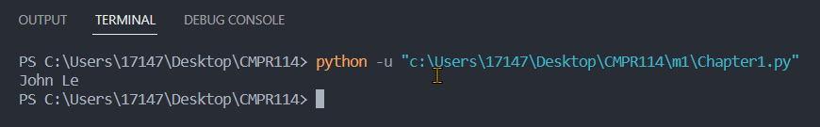

Code:

print("John Le")

1. Using comments in Python. Comments will turn a green color. Notice that we use a # or pound symbol.

1. A variable is a name that is stored in the computer’s memory. Here we are declaring three variables: the name, age, and address. The + symbols mean to concatenate or bind the variables.

Sample output

1. Notice that when you delete the double quotes from the age, it will give you an error. This is because we will have to convert using the **str** function.

1. Input into Python. Notice that we use the input function to allow the user to enter data.

Sample output

1. Using the input function.

1. Using the input function, the str is used to convert a string.

1. Calculating.

**Challenge Exercise #2:** modify #10 (above) and use the input function for the salary and bonus.

**#2 Print screen the code with the output below here.**

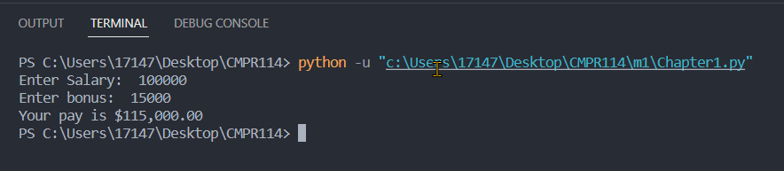

Code:

salary = float(input("Enter Salary: "))

bonus = float(input("Enter bonus: "))

pay = salary + bonus

print("Your pay is ${:,.2f}".format(pay))

1. Using the \n nextline method

1. **Challenge Exercise #3**: write a program that will ask the user the first, and last name, address, city, and state with zip code.

**#3 Print screen the code with the output below here.**

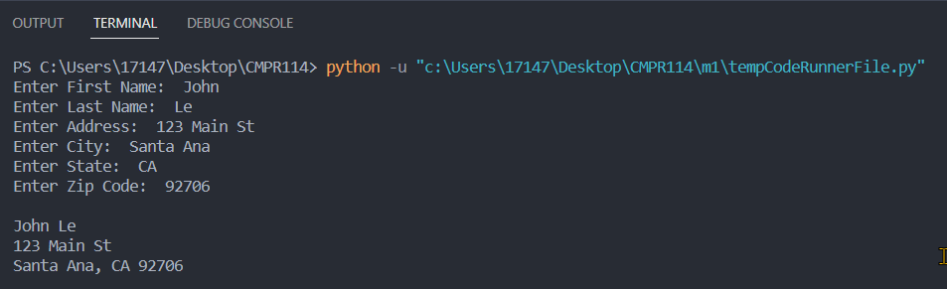

Code:

firstname = input("Enter First Name: ")

lastname = input("Enter Last Name: ")

address = input("Enter Address: ")

city = input("Enter City: ")

state = input("Enter State: ")

zipcode = str(input("Enter Zip Code: "))

print("\n" + firstname + " " + lastname + "\n" +

address + "\n" +

city + ", " + state + " " + zipcode + "\n")

1. Using arithmetic operations.

Sample output

1. **Challenge Exercise #4**: write a program that will ask to enter the last and first names, the hours, with pay for two people, then get the output. Finally, get the *average* pay of the two people. See page 58 in the spotlight for some examples.

**#4 Print screen the code with the output below here.**

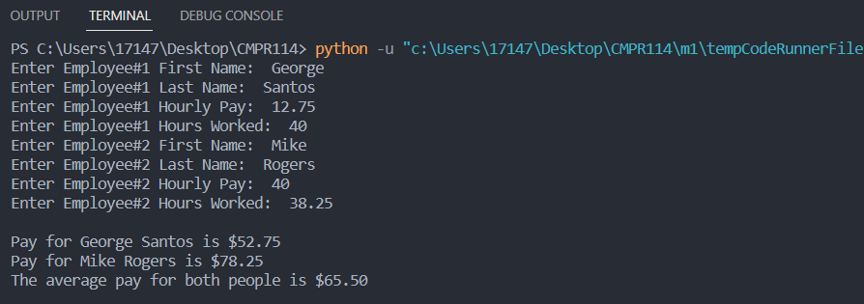

Code:

firstname1 = input("Enter Employee#1 First Name: ")

lastname1 = input("Enter Employee#1 Last Name: ")

hourlypay1 = float(input("Enter Employee#1 Hourly Pay: "))

hoursworked1 = float(input("Enter Employee#1 Hours Worked: "))

subtotal1 = hourlypay1 + hoursworked1

firstname2 = input("Enter Employee#2 First Name: ")

lastname2 = input("Enter Employee#2 Last Name: ")

hourlypay2 = float(input("Enter Employee#2 Hourly Pay: "))

hoursworked2 = float(input("Enter Employee#2 Hours Worked: "))

subtotal2 = hourlypay2 + hoursworked2

avgpay = (subtotal1 + subtotal2) / 2

print("\nPay for " + firstname1 + " " + lastname1 + " is ${:,.2f}".format(subtotal1))

print("Pay for " + firstname2 + " " + lastname2 + " is ${:,.2f}".format(subtotal2))

print("The average pay for both people is ${:,.2f}".format(avgpay) + "\n")

1. **Challenge Exercise #5**: turn to page 55 and complete the Spotlight (Calculating a percentage).

**#5 Print screen the code with the output below here.**

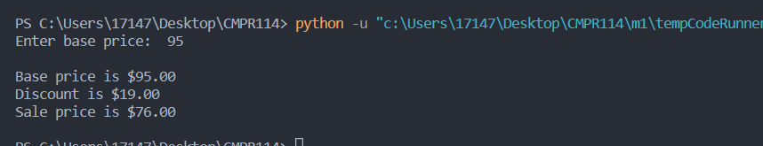

Code:

baseprice = float(input("Enter base price: "))

discountpct = .20

discountval = baseprice * discountpct

saleprice = baseprice - discountval

print("\nBase price is ${:,.2f}".format(baseprice))

print("Discount is ${:,.2f}".format(discountval))

print("Sale price is ${:,.2f}".format(saleprice) + "\n")

1. **Challenge Exercise #6:** Complete the following program below.

**#6 Print screen the code with the output below here.**

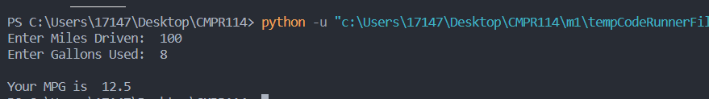

Code:

miles = float(input("Enter Miles Driven: "))

gallons = float(input("Enter Gallons Used: "))

mpg = miles / gallons

print("\nYour MPG is ", mpg)

**Submit this document to module 1 class exercise.**